

**EDS Assignment**

**Name: - Pratik Dhanaji Mane**

**Class: - CS7**

**Roll No.: - CS7-58**

**PRN: - 202401110033**

**OPINRANK Review DATASET ON DELHI HOTELS**

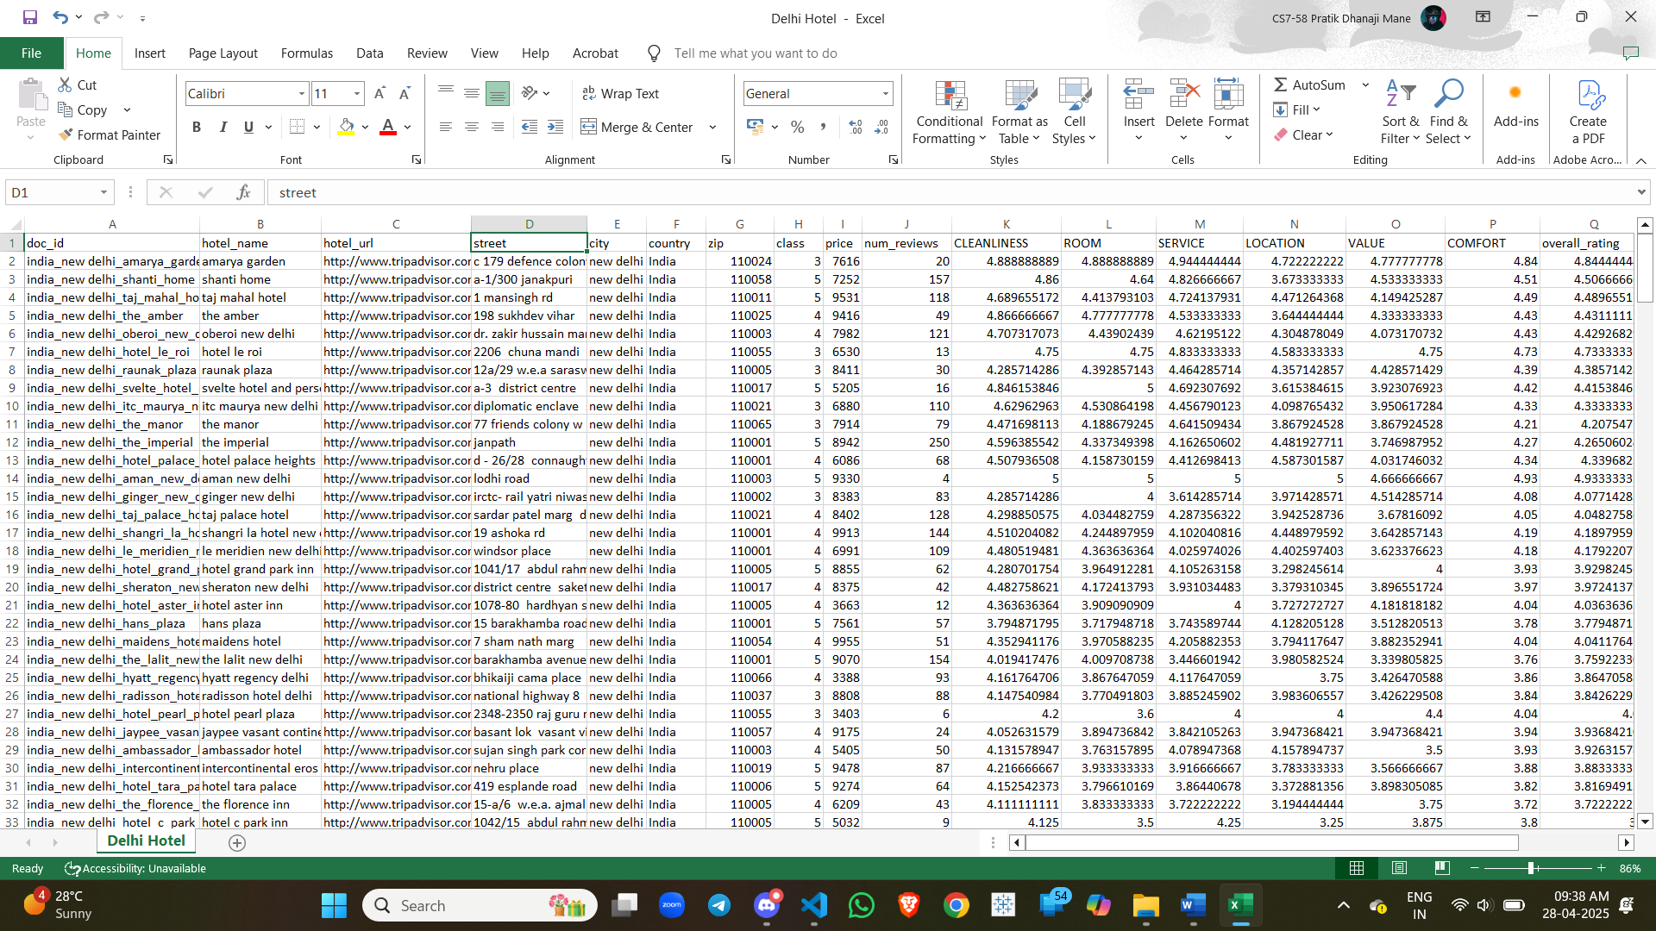



**Display of data in Python**

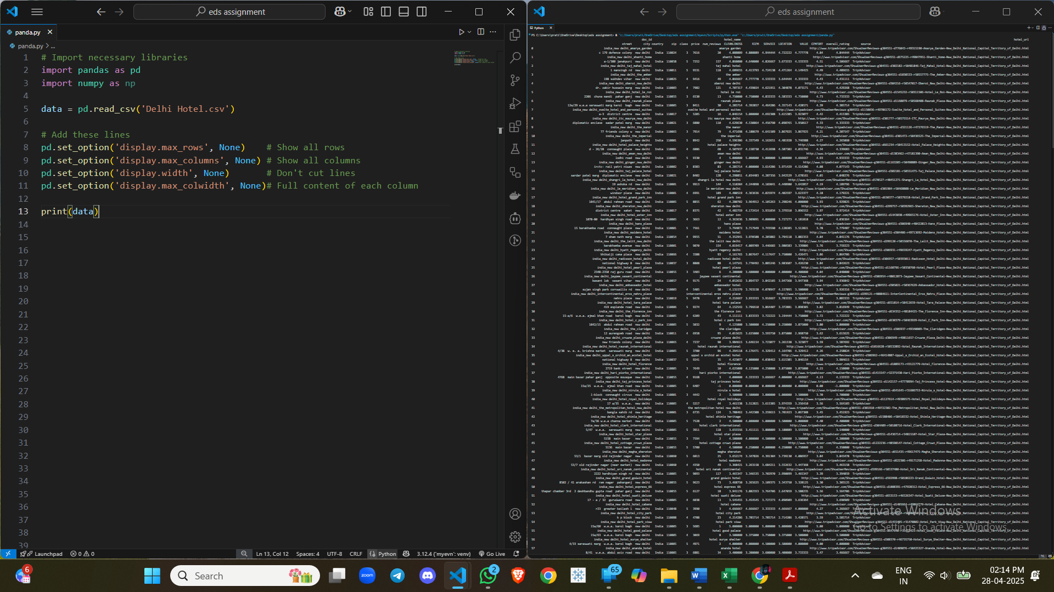

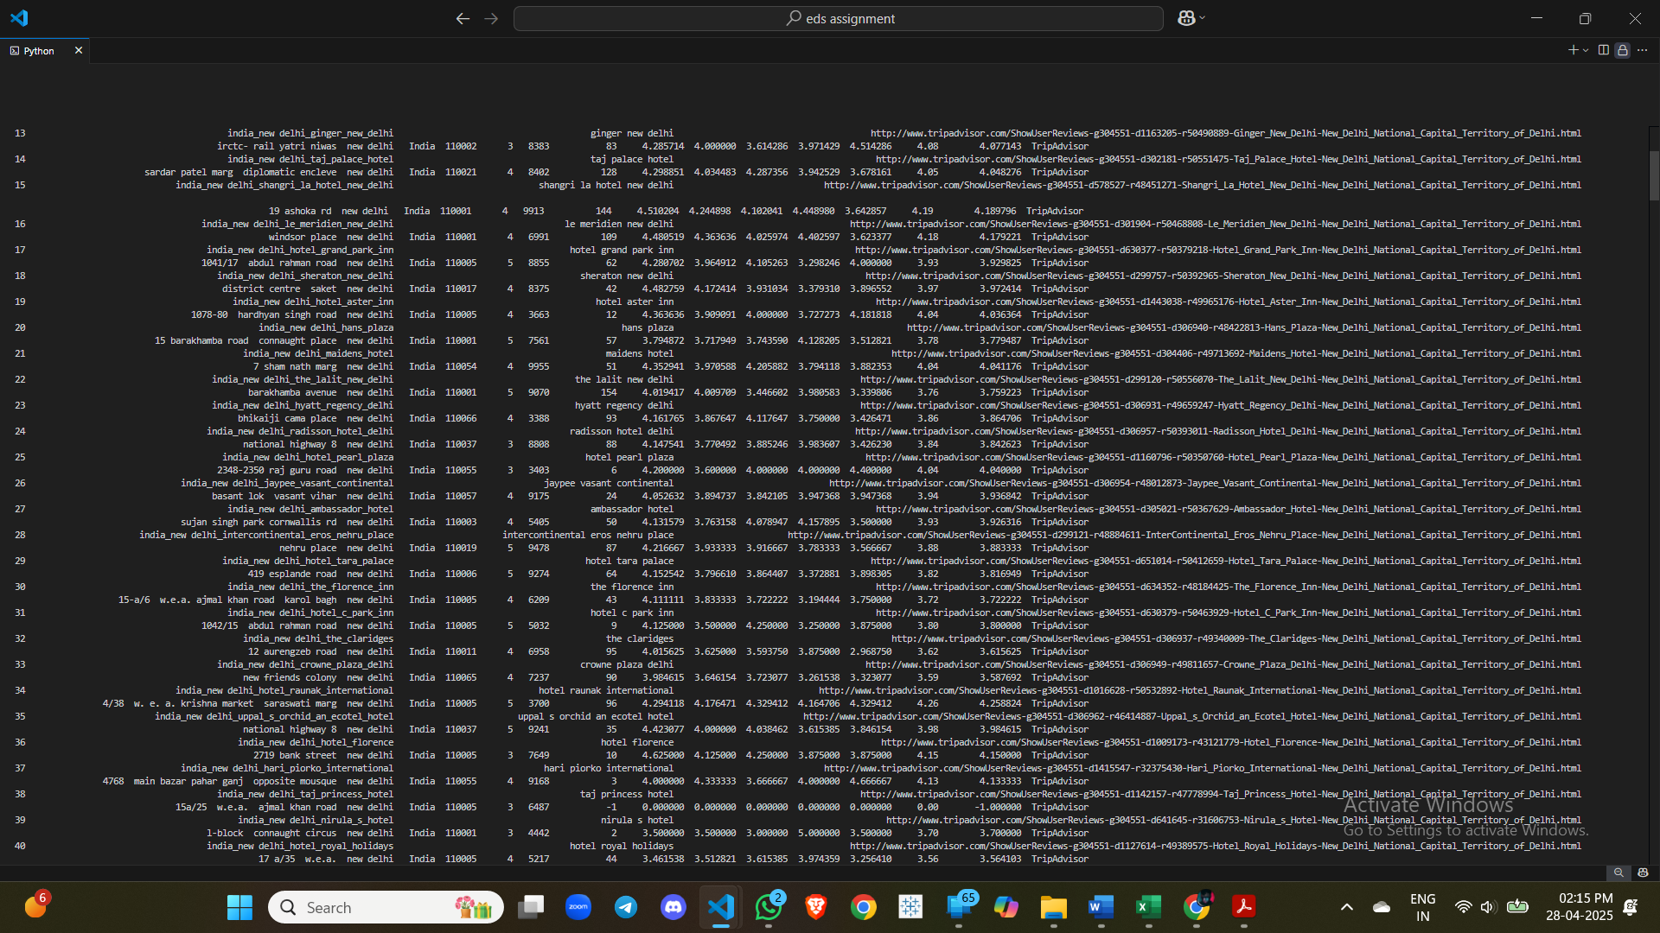

1. Find the hotel(s) with the highest number of reviews.

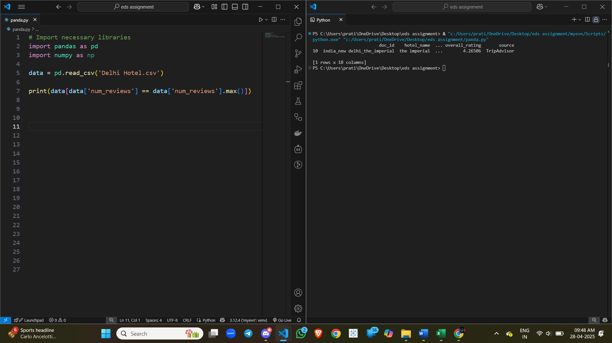

1. Find hotel with highest overall rating

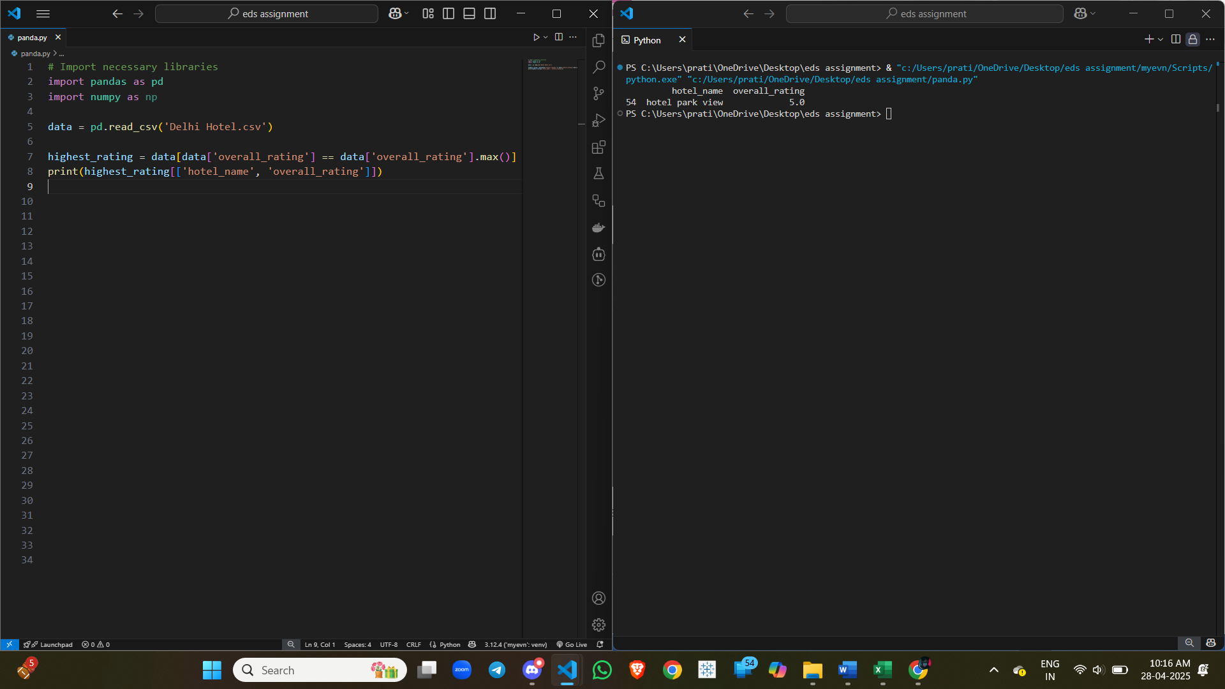

**3.** Find the standard deviation of CLEANLINESS scores overall.

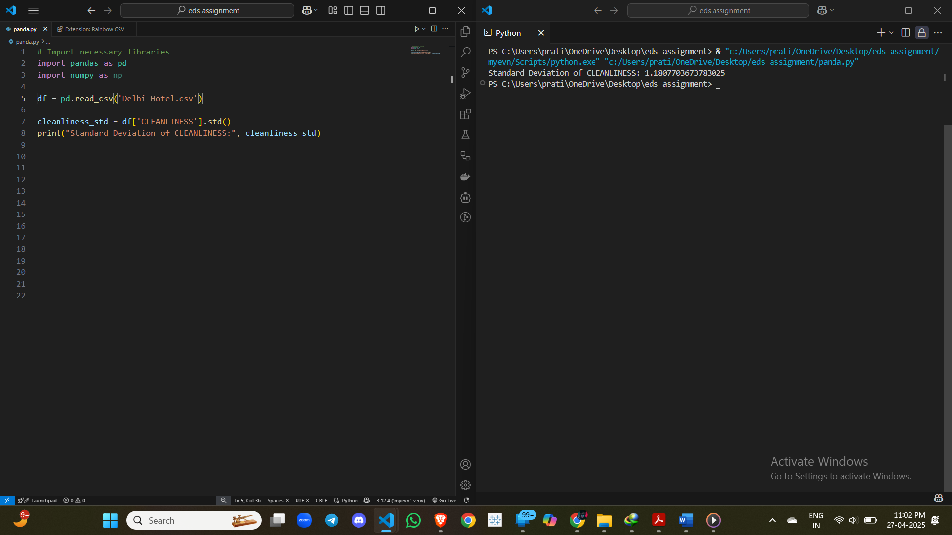

**4.** Find the number of hotels with VALUE score greater than 4.

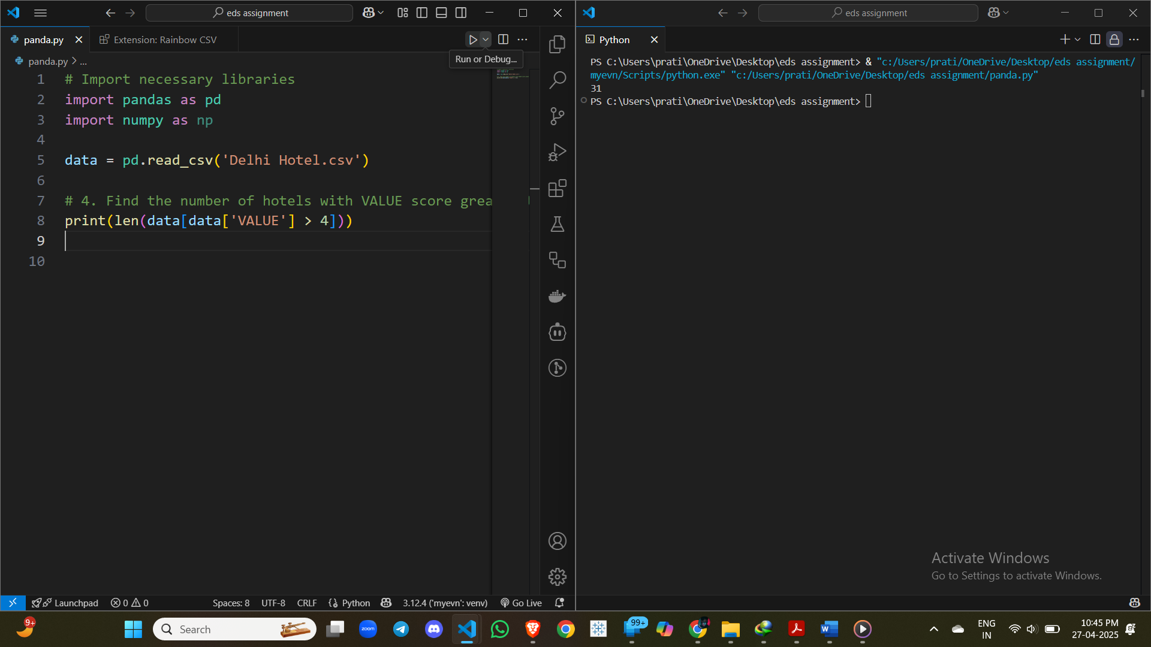

**5.** List hotels where SERVICE rating is lower than LOCATION rating.

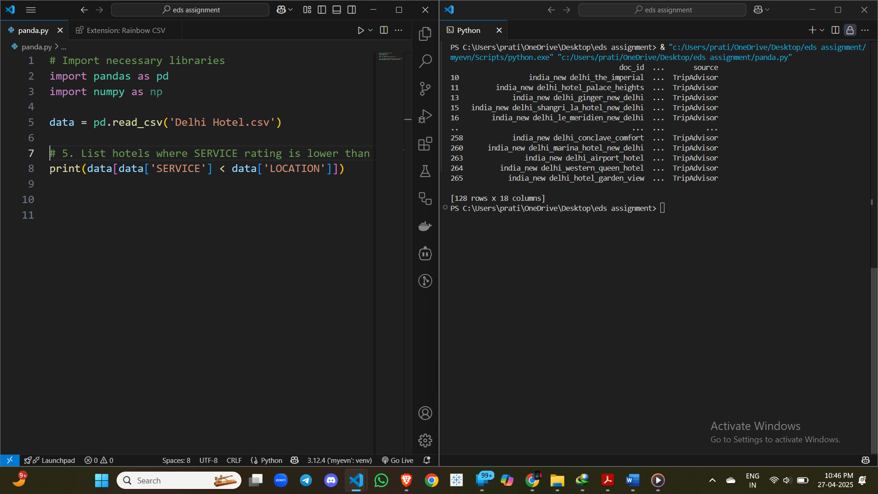

**6.** Calculate average ROOM rating for each hotel class (star rating).

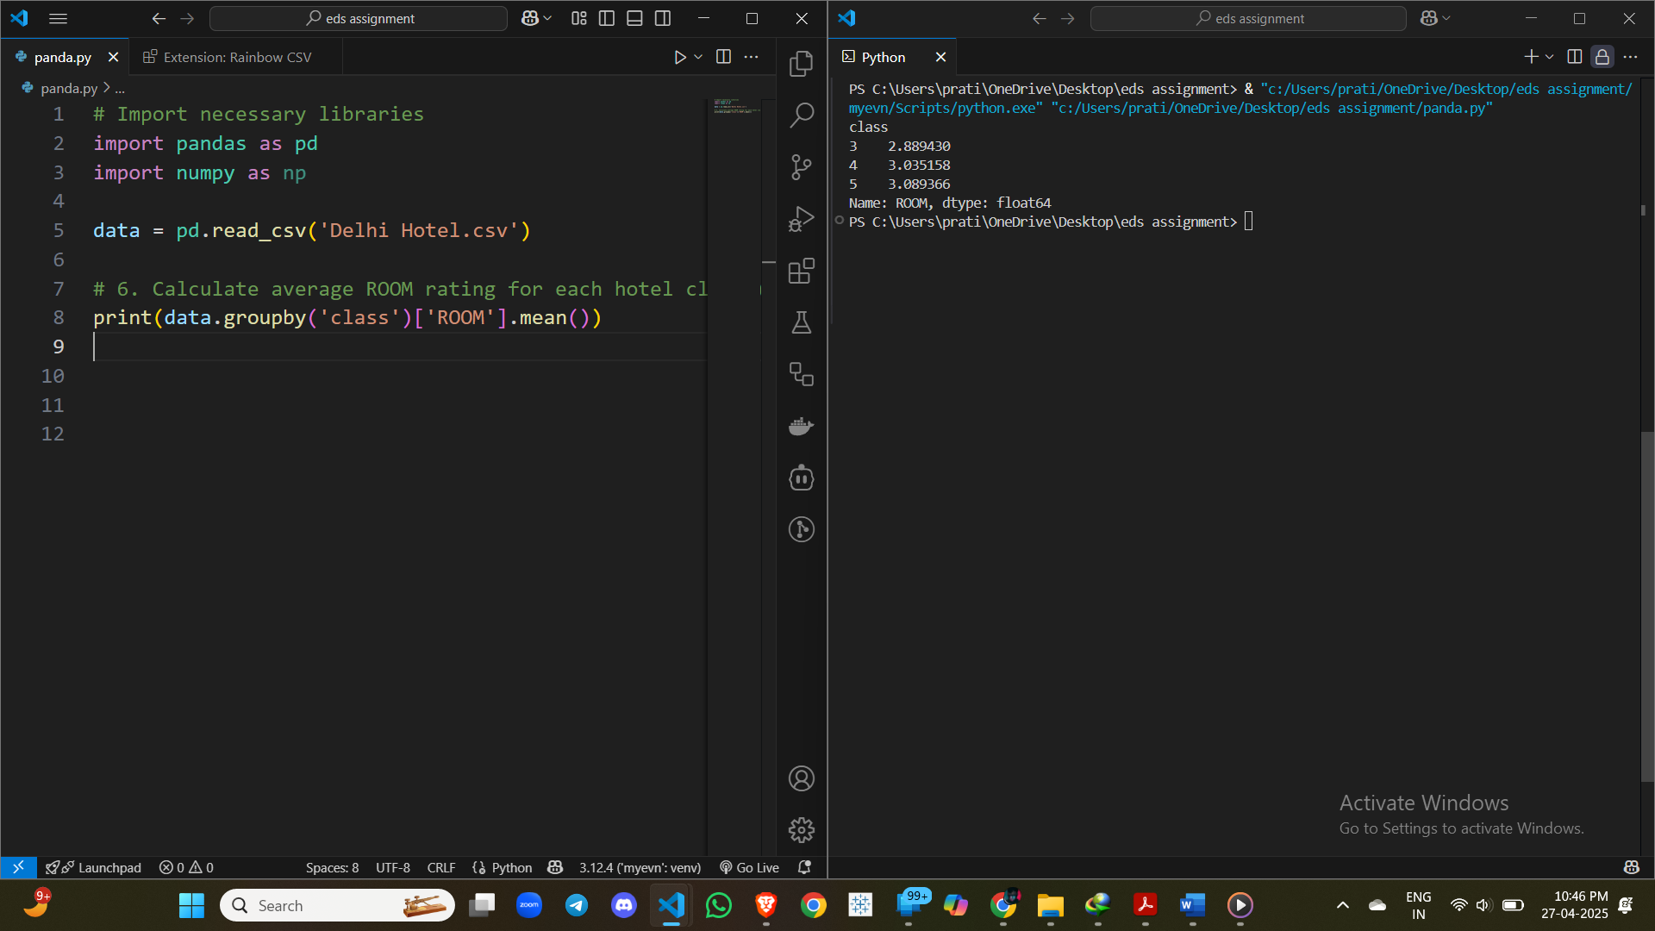

**7.** **Find number of hotels for each star rating (class)**

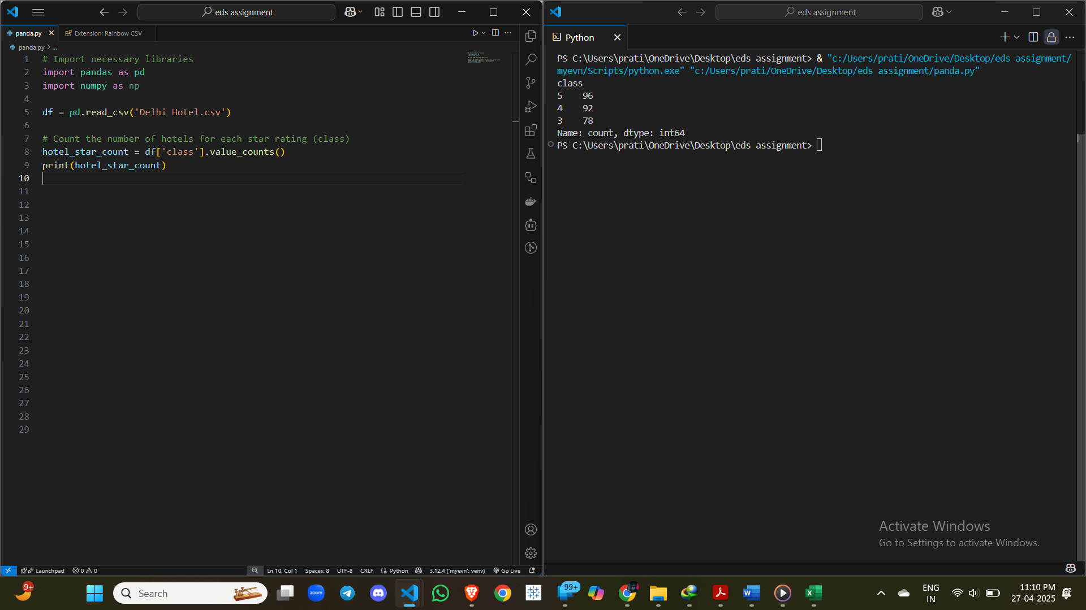

**8.** Find hotels where overall rating is above average overall rating.

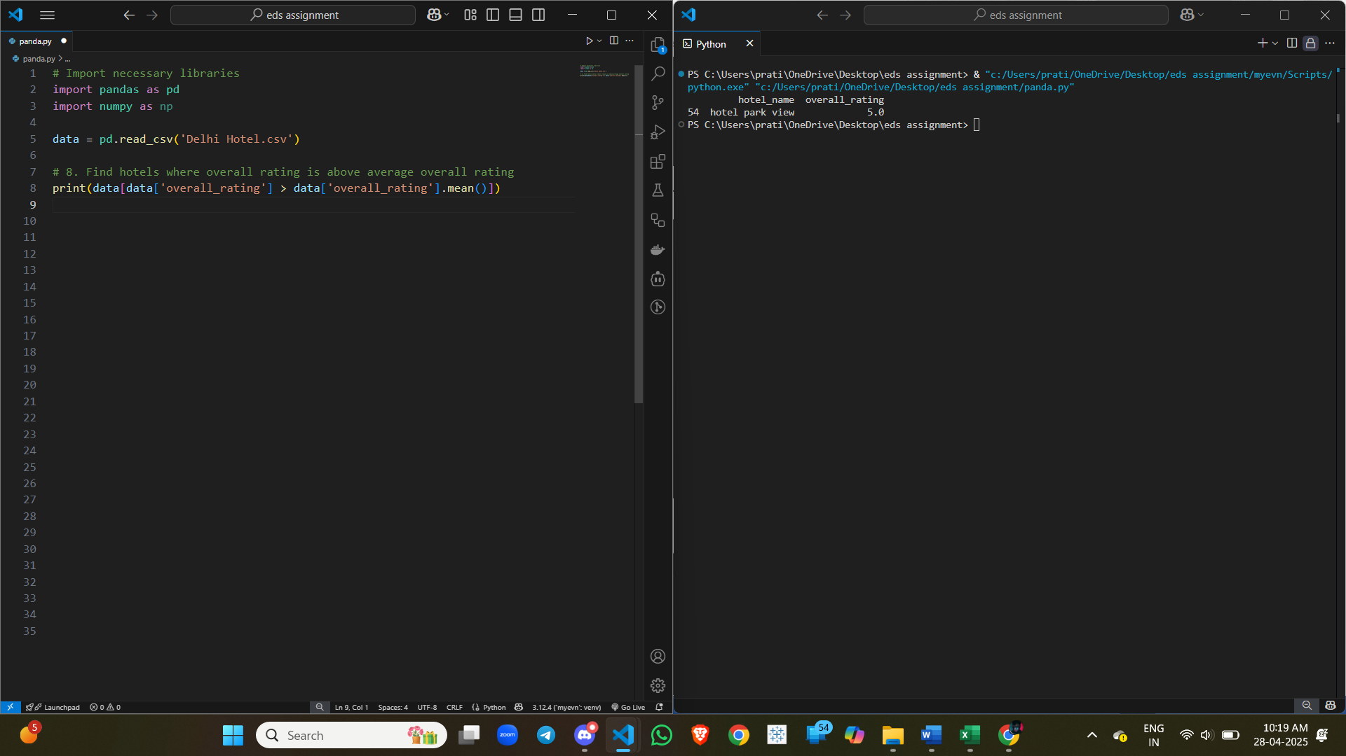

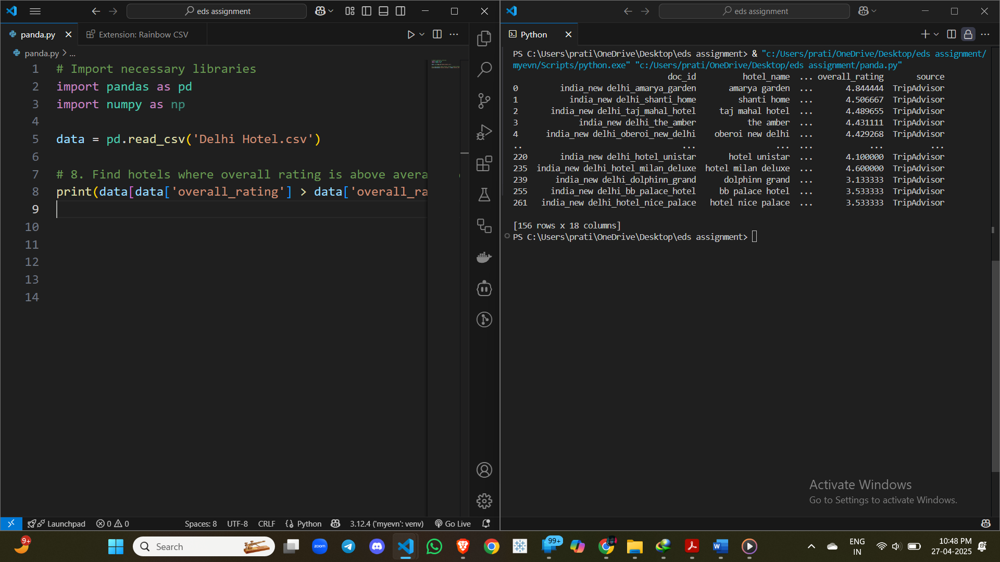

**9.** Calculate the median price in the city.

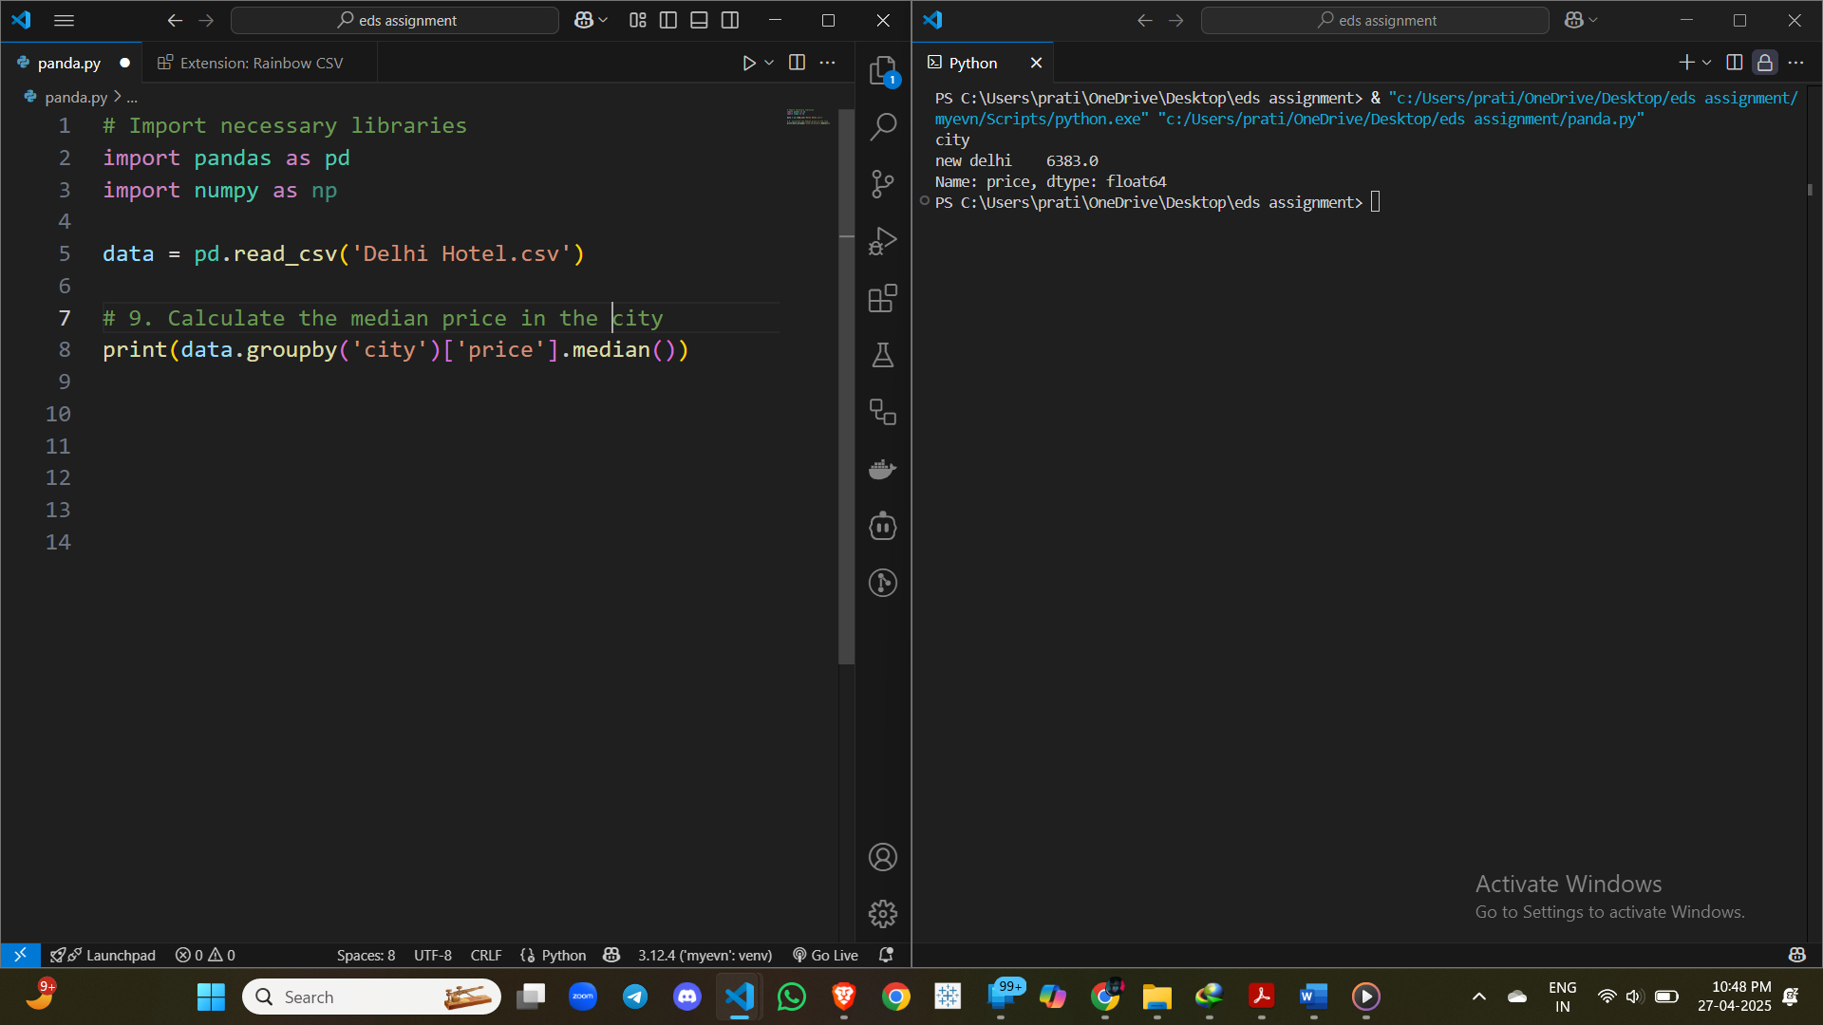

**10.** List all hotels where COMFORT score is less than 2.5.

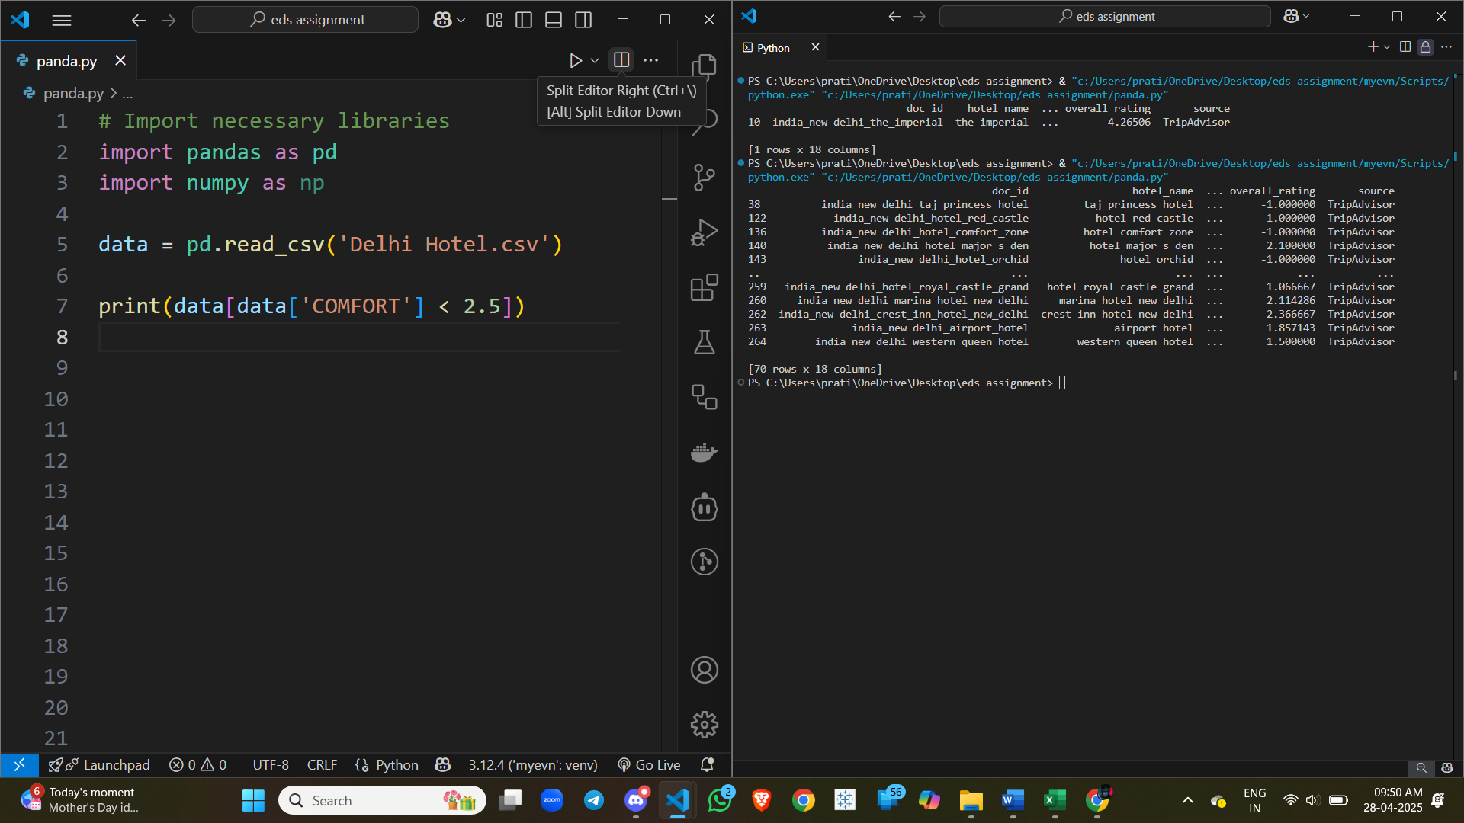

**11.** List hotels where price is greater than 8000 and overall rating is greater than 4.

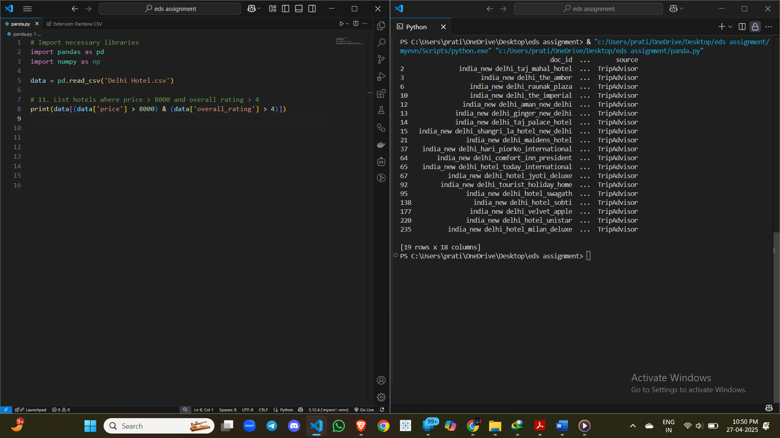

**12.** Find the percentage of 5-star hotels among all hotels.

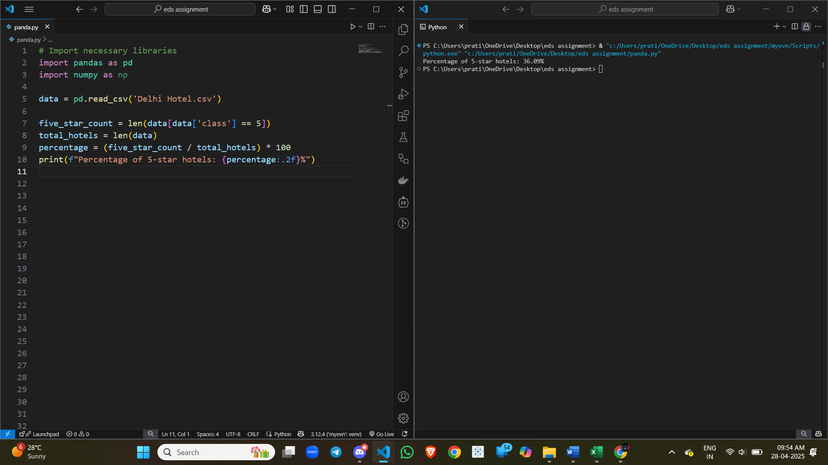

**13. Find the number of hotels where VALUE rating is greater than COMFORT rating.**

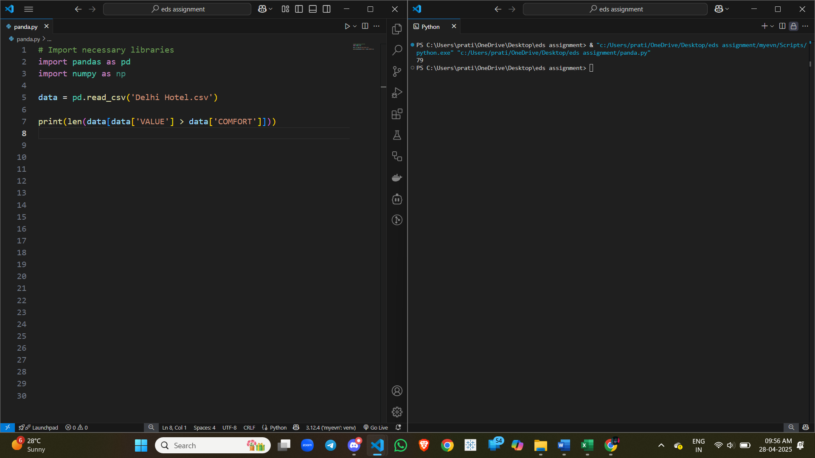

**14.** Find hotels where CLEANLINESS score is less than 2.

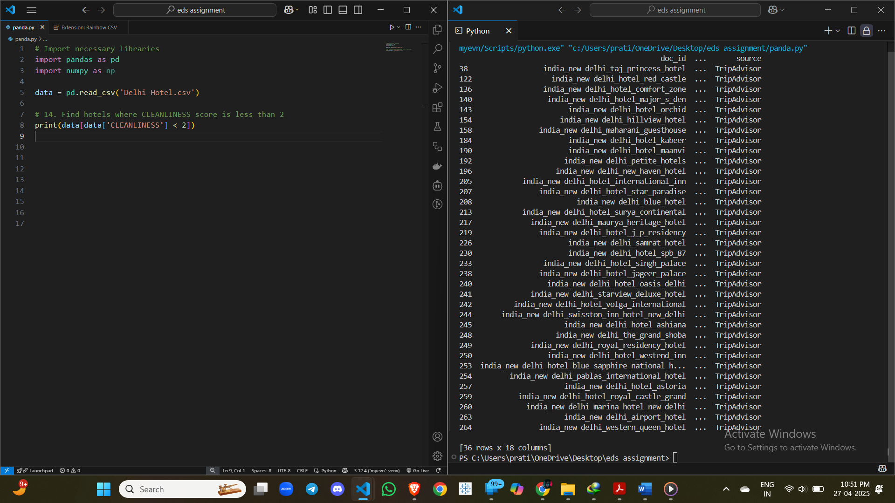



**15.** Calculate average VALUE rating per hotel class.

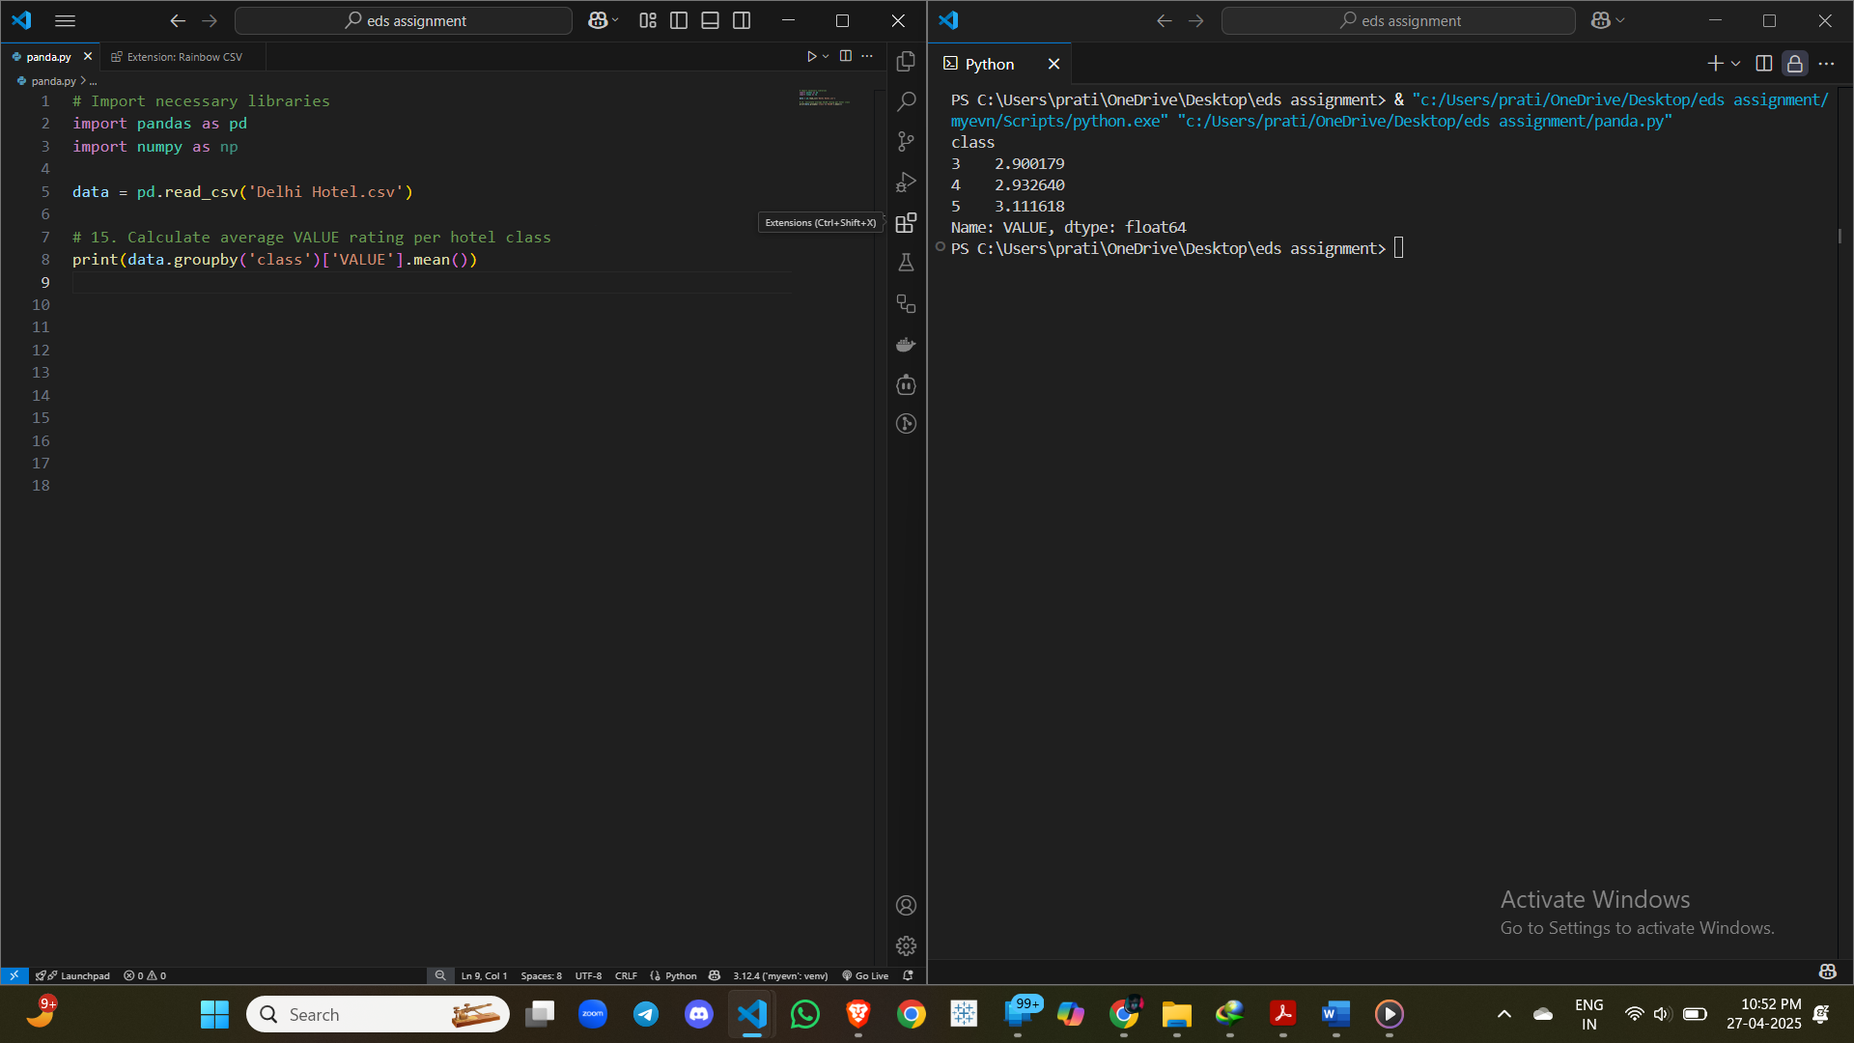

**16.** Find hotels that have a LOCATION score greater than SERVICE score.

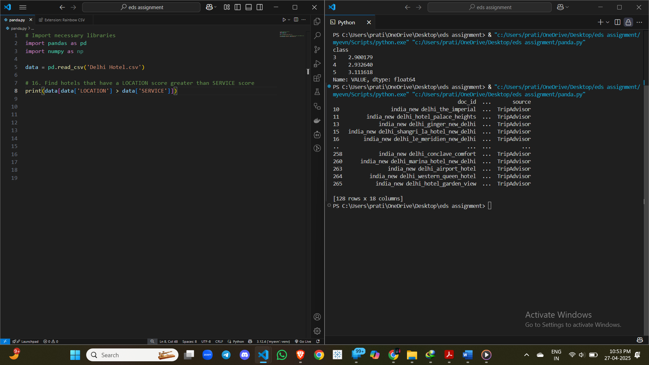

**17.** Calculate average price for each class of hotel.

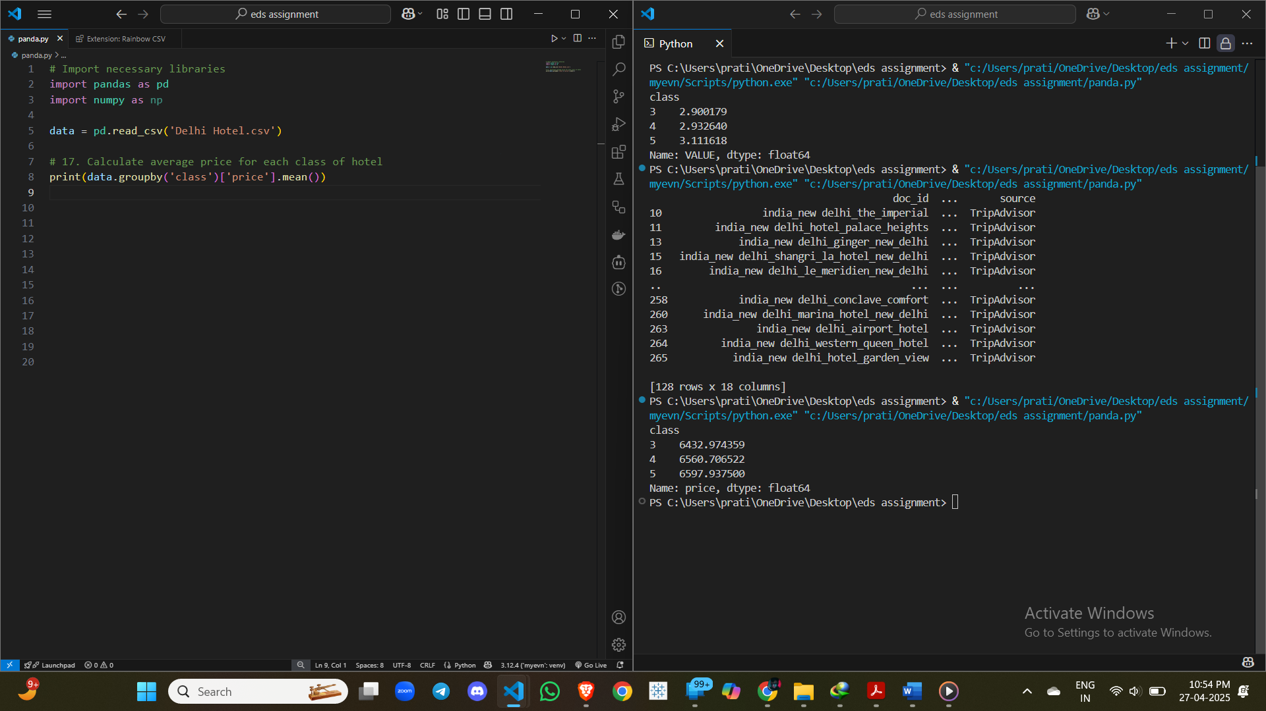



**18.** Create a new column 'Expensive' and set it to 1 for hotels where the price is greater than 7000 and the COMFORT score is less than 3. Otherwise, set it to 0.

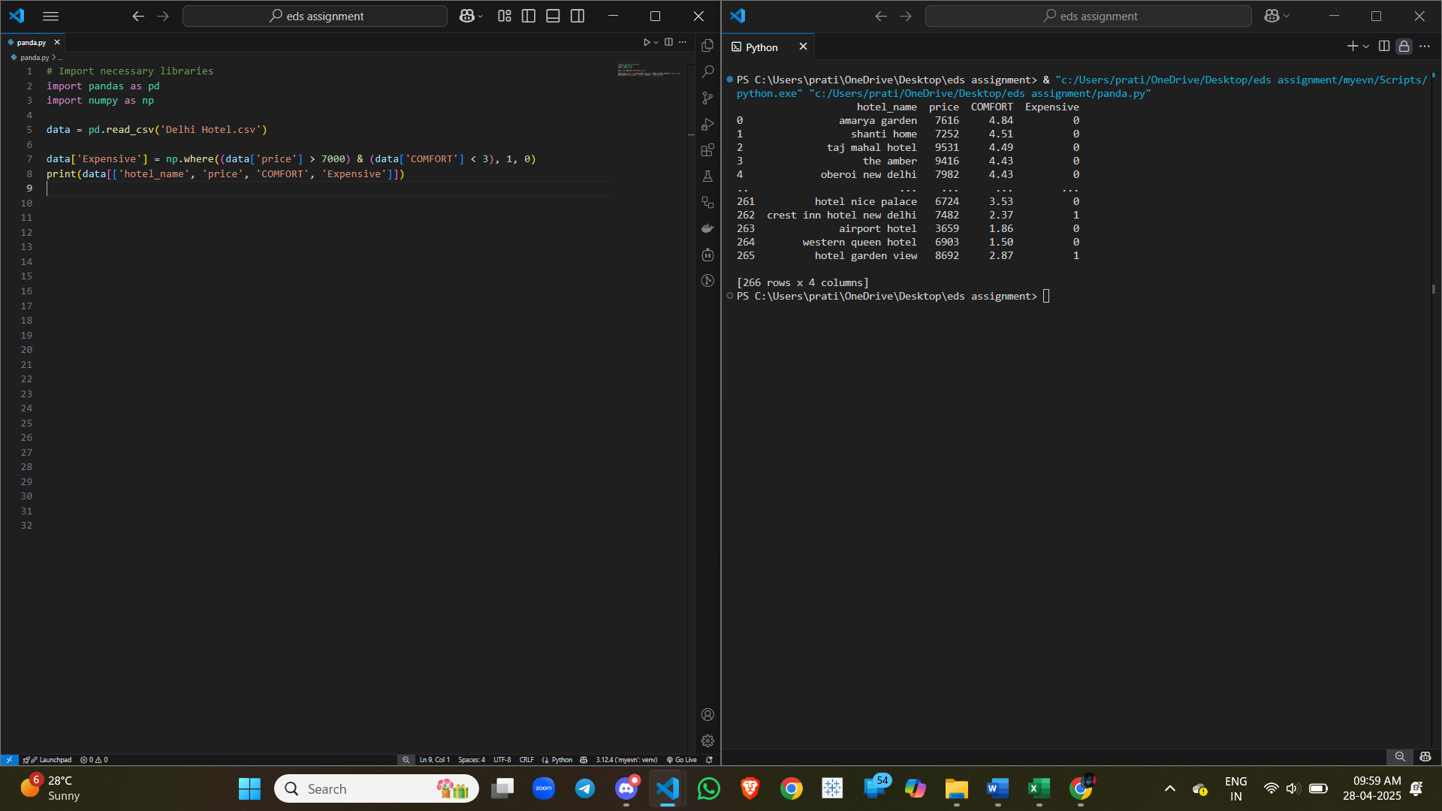

**19.** Find the total number of hotels where VALUE rating is less than 3.

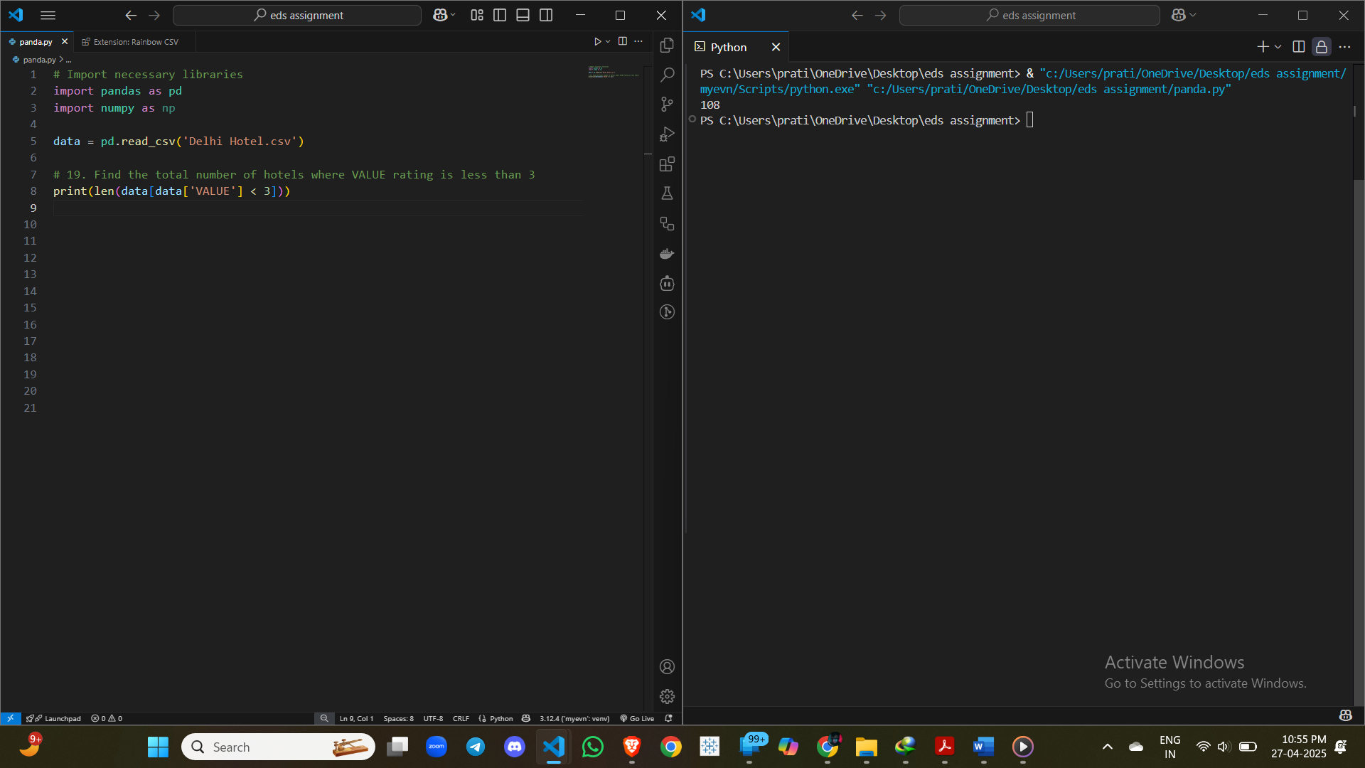

**20.** Create a new column 'Budget' and set it to 1 for hotels with price less than 4000 and COMFORT score greater than 3, else 0.

